Compute gender-wise average weight using Map-Reduce and Aggregation.

Map-Reduce code

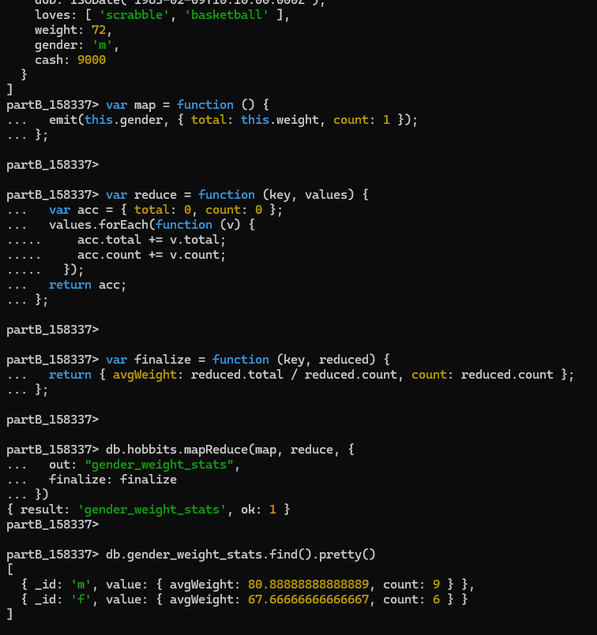

Aggregation pipeline operators

